CAD Design Internship
Master Report: Weeks 1 to 4
AutoCAD | SolidWorks | Drafting
Name: Modi Dhruv Bhaveshbhai
Programme: B.Tech Mechanical Engineering, Government Engineering College, Patan
Software: SolidWorks Premium 2024 SP1.0, AutoCAD
Standards: ISO drafting, first-angle projection, MMGS units

Contents
Part | Title | Main work
Week 1 | Foundations of CAD Design | Fundamentals, tool setup, working setup screenshot
Week 2 | Hands-on Practice | Slotted Link Plate: 3D model, drawing, AutoCAD redraw
Week 3 | Real-world Mini Project | Slider-crank mechanism, remodelled connecting rod, motion study
Week 4 | Capstone and Presentation | Final design, validation, review, presentation summary
Appendix A | Figure checklist | Embedded images and screenshots still to add

Overview
- Week 1 builds the CAD fundamentals and the working setup.
- Week 2 applies them to a fully defined Slotted Link Plate.
- Weeks 3 and 4 build and finalise a slider-crank mechanism around a connecting rod whose dimensions come from a credited reference drawing.
- The connecting rod was remodelled from scratch; the reference model is shown only as a credited source.

Week 1 Report: Foundations of CAD Design
CAD Design Intern | Skills: AutoCAD, SolidWorks, Drafting
Name: Modi Dhruv Bhaveshbhai
Programme: B.Tech Mechanical Engineering, Government Engineering College, Patan
Task: Week 1 - Foundations of CAD Design

1. Introduction
Computer-Aided Design (CAD) is the use of software to create, modify, analyse and document designs. It replaces manual drawing boards with precise digital models. In mechanical engineering, CAD is used for parts, assemblies, manufacturing drawings and simulation. This week I studied the core concepts, installed the tools and learned how professionals structure their CAD work.

2. Fundamentals of CAD

2.1 2D CAD vs 3D CAD
- 2D CAD: Flat drawings made of lines, arcs and circles. Used for plans, layouts and manufacturing drawings.
- 3D CAD: Solid models with volume, mass and material properties. Used for parts, assemblies and simulation.
- Workflow link: 2D drawings are usually generated from the 3D model for shop-floor use.

2.2 Core CAD concepts
- Sketches and constraints: 2D profiles with geometric relations (horizontal, tangent, concentric) and dimensions.
- Features: Extrude, revolve, sweep, loft, fillet, chamfer, hole and pattern.
- Assemblies: Parts are combined using mates (coincident, concentric, distance).
- Parametric design: Parametric modelling means changing a dimension updates the whole model.
- History-based modelling: A feature tree records the order of operations so the design can be edited later.

2.3 Drafting fundamentals
- Orthographic projection: Front, top and side views using first-angle or third-angle projection.
- Section views: Used to show internal details of a part.
- Dimensioning: Clear, non-repeated dimensions following standards such as ISO and ASME Y14.5.
- Tolerances: Linear, limit and geometric tolerances (GD&T) define allowed variation.
- Drawing sheet elements: Title block, scale, units, line types, layers and revision details.

3. Tools Studied
Tool | Main use | What I practised
AutoCAD | 2D drafting and detailing | Lines, circles, offset, trim, layers, dimension styles
SolidWorks | 3D part and assembly modelling | Sketches, extrude/cut, fillet, assembly mates, drawing views
Drafting standards | Communicating design to manufacturing | Views, dimensions, tolerances, title blocks

4. Setting Up the Environment
- Step 1: Checked system requirements (64-bit OS, adequate RAM, dedicated graphics preferred).
- Step 2: Installed AutoCAD (student/educational version) and SolidWorks Premium 2024 SP1.0.
- Step 3: Set units to millimetres, created drawing templates, and configured layers and dimension styles.
- Step 4: Set up SolidWorks document properties (MMGS units, ISO drafting standard) and a standard part template.
- Step 5: Created a project folder structure for parts, assemblies, drawings and exports.
- Step 6: Opened both tools and created a test sketch to confirm the setup works.

5. How Professionals Work
- Start from design requirements and constraints before opening the software.
- Sketch fully constrained profiles so models stay stable when edited.
- Name features, layers and files clearly and follow company standards.
- Use version control or revision tables for every drawing change.
- Reuse standard parts (fasteners, bearings) from libraries instead of redrawing.
- Review models and drawings for errors before release to manufacturing.
- Export in standard formats (STEP, DXF, PDF) for sharing with other teams.

6. Practice Exercise
- Drew a simple plate with holes in AutoCAD using layers and dimensions.
- Modelled the same plate in SolidWorks using extrude, cut and fillet features.
- Created a fully defined test sketch, the Slotted Link Plate (see Section 7), with a 20 mm hole, a 12 mm slot, R15, R30 and R50 arcs and linear dimensions.
- Generated a 2D drawing from the 3D model with front, top and side views.

7. Screenshot of Working Setup
The screenshot shows SOLIDWORKS Premium 2024 SP1.0 working in the MMGS unit system. The test sketch, Sketch3 of Slotted Link Plate.SLDPRT, is drawn on the Top Plane and is Fully Defined, as shown in the status bar.
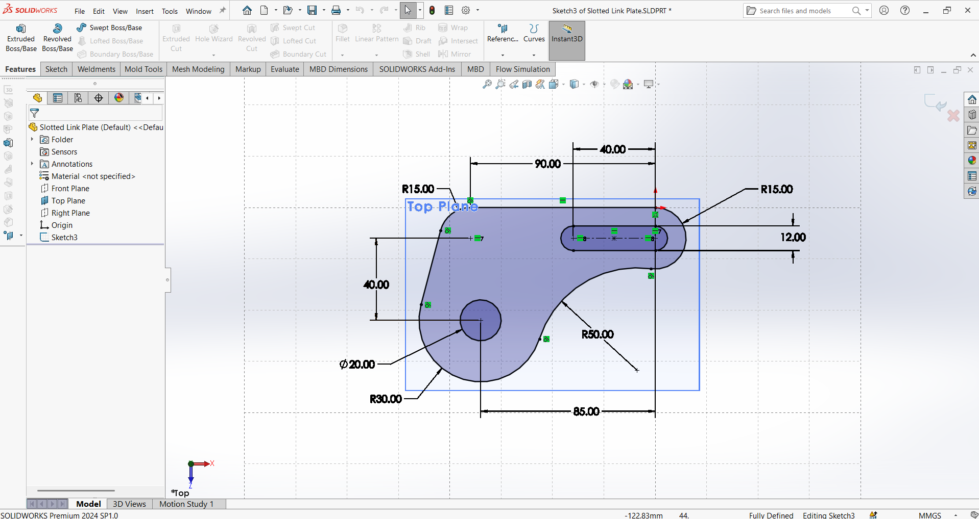
Figure 1: Working SolidWorks setup with the Slotted Link Plate test sketch

8. Key Learnings and Next Steps
- CAD is about design intent, not just drawing shapes.
- Constraints and clear structure make models easy to edit.
- Good drafting practice is as important as good modelling.
- Next: more complex parts, assemblies, and tolerance and GD&T practice.

Week 2 Report: Hands-on Practice in CAD Design
CAD Design Intern | AutoCAD, SolidWorks, Drafting
Name: Modi Dhruv Bhaveshbhai
Programme: B.Tech Mechanical Engineering, Government Engineering College, Patan
Task: Week 2 - Hands-on Practice

1. Exercise Overview
- Part: Slotted Link Plate, a link that pivots on a Ø20 hole and guides a pin through a 12 mm slot.
- Why this part: It combines holes, a slot, tangent arcs and a concave blend, so it practises most sketching skills.
- Tools: SolidWorks Premium 2024 SP1.0 (3D model and drawing) and AutoCAD (2D redraw).
- Goal: Model it, document it and draw it using professional best practice.
- My design choices: 10 mm thickness, plain carbon steel, units in MMGS, ISO drafting standard.

2. Key Dimensions
Feature | Dimension
Pivot hole | Ø20 mm
Slot width | 12 mm (R6 ends)
Slot length, centre to centre | 40 mm
Hole centre to slot right end (horizontal) | 85 mm
Hole centre to slot centreline (vertical) | 40 mm
Top edge horizontal dimension | 90 mm
Corner and slot-end arcs | R15
Lower boss arc around pivot hole | R30
Concave blend arc | R50

3. Step-by-Step Approach

3.1 SolidWorks 3D model
- Step 1 - Sketch: Opened a new part, saved it as Slotted Link Plate, and sketched the profile on the Top Plane.
- Step 2 - Constrain: Added tangent, horizontal and coincident relations first, then dimensions, until the status bar showed Fully Defined (Figure 1).
- Step 3 - Extrude: Used Extruded Boss/Base with a 10 mm thickness.
- Step 4 - Finish edges: Added a small chamfer on the pivot hole and slot edges to remove sharp edges.
- Step 5 - Material: Assigned Plain Carbon Steel, since the feature tree showed material as not specified.
- Step 6 - Check: Ran Evaluate > Mass Properties to confirm mass and centre of mass.

3.2 SolidWorks drawing
- Created an A3 drawing sheet in ISO standard with first-angle projection.
- Inserted front, top and right views plus an isometric view from the 3D model.
- Added model dimensions, a centre mark for the hole, a title block and a scale note.

3.3 AutoCAD 2D redraw
- Set units to millimetres and created layers: Outline, Centre, Dimension and Text.
- Drew the profile with LINE, CIRCLE and ARC, then used OFFSET, TRIM and FILLET to build the shape.
- Dimensioned with DIMLINEAR, DIMDIAMETER and DIMRADIUS.
- Compared the AutoCAD dimensions with the SolidWorks model to confirm both match.

4. Best Practices Followed
- Fully defined sketches so the model stays stable when edited.
- Relations added before dimensions, so design intent drives the geometry.
- Clear file, feature and layer names.
- Material assigned early so mass data is meaningful.
- Drawing created from the 3D model, so both always agree.
- No repeated or conflicting dimensions on the drawing.

5. Results and Screenshots
Figure 1: Fully defined Slotted Link Plate sketch in SolidWorks (Sketch3, Top Plane, MMGS)
[Insert Figure 2: extruded 3D model of the Slotted Link Plate in SolidWorks]
[Insert Figure 3: SolidWorks drawing sheet with views, dimensions and title block]
[Insert Figure 4: AutoCAD 2D drawing of the plate with layers and dimensions]

6. Checks Performed
- Sketch status: Fully Defined.
- Extrusion thickness measured at 10 mm.
- Drawing dimensions match the model dimensions.
- AutoCAD dimensions match SolidWorks dimensions.

7. Learnings
- Order matters: relations first, dimensions second.
- A fully defined sketch is the base of an editable model.
- Making both a 3D model and a 2D drawing of the same part builds understanding of how they link.
- Next: use this part in an assembly (Week 3).

Week 3 Report: Real-world Mini Project
Slider-Crank Mechanism with Connecting Rod | AutoCAD, SolidWorks, Drafting
Name: Modi Dhruv Bhaveshbhai
Programme: B.Tech Mechanical Engineering, Government Engineering College, Patan
Task: Week 3 - Real-world Mini Project

1. Project Overview
- Project: A miniature slider-crank mechanism (crankshaft, connecting rod, piston, wrist pin and cylinder block) that turns rotary motion into straight-line motion.
- Real-world use: The same mechanism is used in engines, compressors, pumps and presses.
- How it works: The crank pin rotates about the shaft axis. The connecting rod links the crank pin to the piston, and the piston slides in the cylinder bore.
- Why this project: It uses every skill from Weeks 1 and 2: sketches, extrudes, fits, assembly mates, motion, drawings and a BOM.

2. Reference Model Credit and Originality
- Reference: I downloaded the file 000030_Connecting_Rod (a CATIA V5 STEP file and a PDF drawing created by Kerem KA, ISTUN, dated 12.05.2026).
- How I used it: Only as a dimension reference. I did not use the imported solid in my assembly.
- My own work: I remodelled the connecting rod from scratch in SolidWorks, using fully defined sketches and my own feature tree.
- Everything else: The crankshaft, piston, wrist pin, cylinder block, base plate, mates, motion study and drawings are my own design and work.
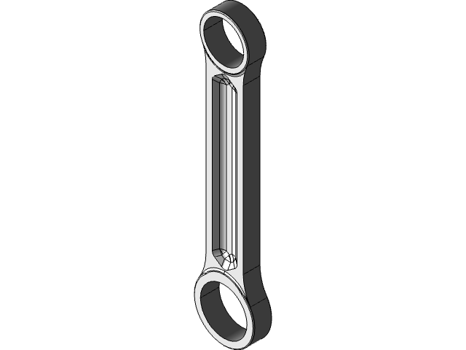
Figure A: Reference connecting rod (downloaded model, used only to read dimensions)
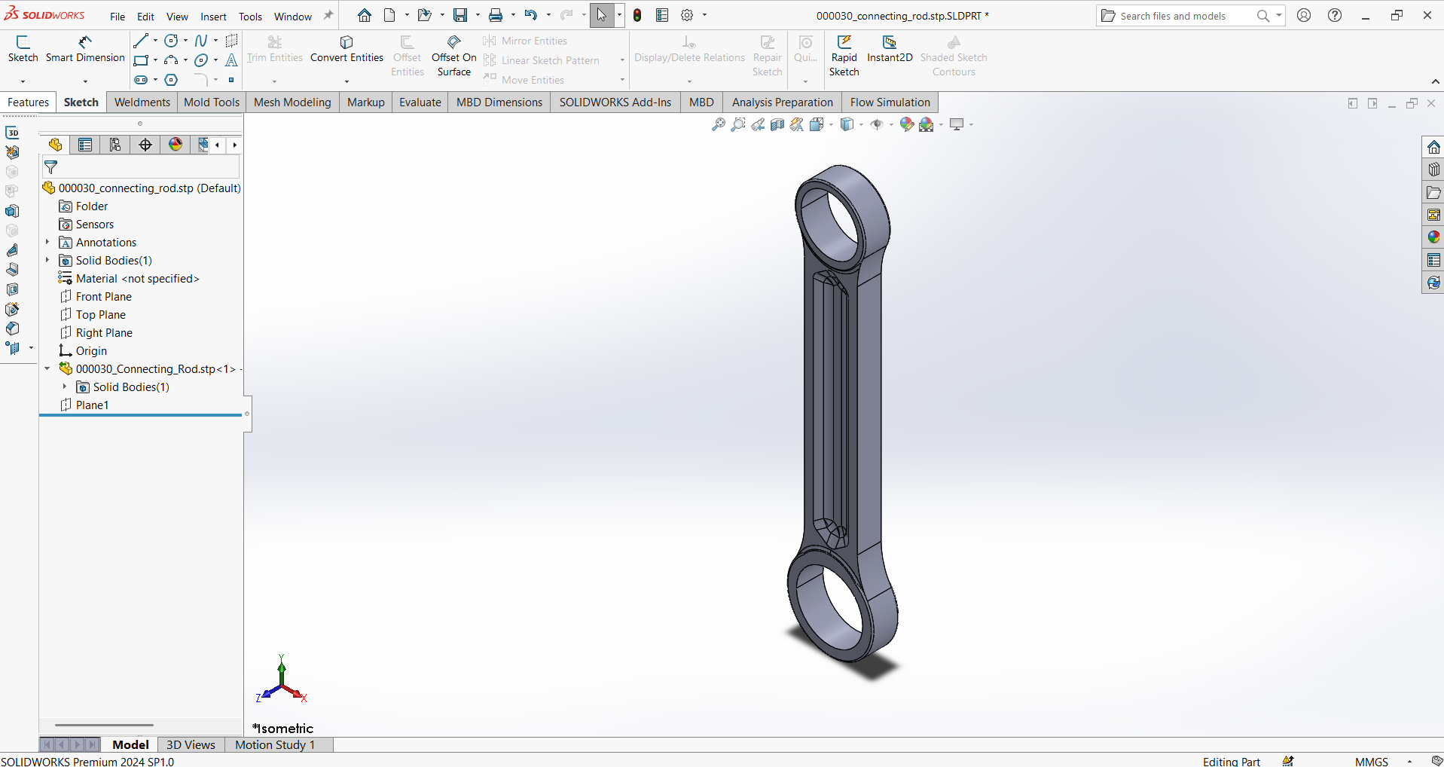
Figure B: Reference STEP file opened in SolidWorks 2024 SP1.0 (imported solid with no features)

3. Requirements
ID | Requirement | How it is met
R1 | Convert crank rotation into piston motion | Slider-crank geometry with 8 mm crank radius
R2 | Stroke of 16 mm | Stroke = 2 x crank radius = 2 x 8
R3 | Smooth running with no binding | Clearance fits on all moving joints
R4 | Piston stays inside the bore at all positions | Checked in the motion study at 0 to 360 deg
R5 | Rod dimensions follow the reference drawing | 25 mm centre distance and bore sizes as per the drawing
R6 | Fully documented | BOM, assembly drawing, detail drawings, tolerances

4. Design Decisions
Decision | Choice | Reason
Rod length (centre to centre) | 25 mm | Taken from the reference drawing
Crank radius | 8 mm | Gives rod ratio l/r = 3.125, a normal value for engines
Slider offset | 0 (in line) | Simplest and symmetric motion
Crank pin / big end | Ø5 pin in Ø5 +0.01/0 bore | Matches the rod drawing
Wrist pin / small end | Ø4.3 pin in Ø4.3 +0.01/0 bore | Matches the rod drawing
Pin fit class | g6 pins (-0.004 / -0.012 mm) | Free rotation with small clearance
Piston to bore fit | Ø12 H7 / g6 | Sliding fit
Units and standard | MMGS, ISO, first angle | Consistent with Weeks 1 and 2

5. Bill of Materials
Item | Part | Qty | Material / Standard
1 | Base Plate (60 x 40 x 5) | 1 | Plain carbon steel
2 | Cylinder Block | 1 | Aluminium alloy
3 | Crankshaft (shaft, web disc and crank pin) | 1 | Plain carbon steel
4 | Connecting Rod | 1 | 2024-T4 aluminium (as in the reference drawing)
5 | Piston (Ø12) | 1 | Aluminium alloy
6 | Wrist Pin (Ø4.3 x 11) | 1 | Plain carbon steel
7 | Socket Head Screw M3 x 8 | 4 | ISO 4762

6. Kinematics
- Formula: x = r cos(theta) + sqrt(l^2 - r^2 sin^2(theta)), with r = 8 mm and l = 25 mm. x is the distance from the crank axis to the wrist pin.
- Top dead centre (TDC): x = r + l = 33 mm.
- Bottom dead centre (BDC): x = l - r = 17 mm.
- Stroke: 33 - 17 = 16 mm.
Crank angle | Piston distance from crank axis (mm) | Piston position above BDC (mm)
0 deg (TDC) | 33.00 | 16.00
45 deg | 30.01 | 13.01
90 deg | 23.69 | 6.69
135 deg | 18.69 | 1.69
180 deg (BDC) | 17.00 | 0.00
225 deg | 18.69 | 1.69
270 deg | 23.69 | 6.69
315 deg | 30.01 | 13.01

- Piston travel is not symmetric about 90 degrees: the piston spends more crank angle in the lower half of its stroke because the rod is finite in length.
- I will compare these values with the SolidWorks Motion Study results to validate the model.

7. Part Specifications

7.1 Connecting Rod (remodelled)
Feature | Value (from the reference drawing)
Centre distance | 25 mm
Big end bore | Ø5 +0.01 / 0
Big end outer diameter | Ø6.5 +/-0.05
Small end bore | Ø4.3 +0.01 / 0
Small end outer diameter | Ø5.3 +/-0.05
Thickness at the eyes | 2 +/-0.5 mm
Blend and corner radii | R5 x 4, R0.3 for unspecified radii
Material | 2024-T4 aluminium
General tolerance | ISO 2768-m

7.2 Other parts (my design choices)
Part | Main features
Crankshaft | Ø6 main shaft g6, Ø22 x 3 mm web disc, Ø5 g6 crank pin at 8 mm from the shaft axis, 6 mm long
Piston | Ø12 g6 x 12 mm long, 2.5 mm wide slot for the rod, Ø4.3 cross hole for the wrist pin
Wrist pin | Ø4.3 g6 x 11 mm; shorter than the piston diameter so the bore wall keeps it in place
Cylinder Block | Ø12 H7 bore, Ø6 H7 shaft bearing hole, 4 x M3 mounting holes
Base Plate | 60 x 40 x 5 mm with 4 tapped M3 holes

8. Fit Analysis
Joint | Hole limits (mm) | Shaft limits (mm) | Clearance (mm)
Big end on crank pin (Ø5) | 5.000 to 5.010 | 4.988 to 4.996 | 0.004 to 0.022
Small end on wrist pin (Ø4.3) | 4.300 to 4.310 | 4.288 to 4.296 | 0.004 to 0.022
Crankshaft in block (Ø6) | 6.000 to 6.012 | 5.988 to 5.996 | 0.004 to 0.024
Piston in bore (Ø12) | 12.000 to 12.018 | 11.983 to 11.994 | 0.006 to 0.035

- All joints are running fits with small clearance, so the mechanism turns freely without noticeable play.
- The g6 and H7 deviations follow the ISO 286 tables for the 3 to 6 mm and 10 to 18 mm size ranges (to be confirmed against the official table).

9. Build Process

9.1 Remodelling the connecting rod
- Step 1: Created a new part in MMGS and sketched the two eye circles on the Front Plane, 25 mm apart.
- Step 2: Drew the outer eye circles (Ø6.5 and Ø5.3) and joined them with tangent lines and R5 blends.
- Step 3: Added relations first (tangent, vertical centre line), then dimensions until the sketch was Fully Defined.
- Step 4: Extruded the profile to the 2 mm thickness.
- Step 5: Cut the bores Ø5 and Ø4.3 with the drawing tolerances.
- Step 6: Cut the recessed web on the beam and added the R0.3 and R1 fillets.
- Step 7: Assigned 2024-T4 aluminium and checked mass properties.

9.2 Other parts and assembly
- Modelled the crankshaft by revolving the shaft and extruding the web and crank pin.
- Modelled the piston, wrist pin, cylinder block and base plate with fully defined sketches.
- Inserted the base plate, fixed it, and added mates part by part.

10. Assembly Mates
Parts | Mates used
Cylinder Block and Base Plate | Coincident faces + Concentric screw holes
Crankshaft and Cylinder Block | Concentric (shaft and bearing hole) + Coincident (web face to block face)
Rod and Crank Pin | Concentric (big end and crank pin) + Coincident (rod face to web)
Rod and Wrist Pin | Concentric (small end and pin)
Wrist Pin and Piston | Concentric (cross hole and pin) + Width mate (pin centred in piston)
Piston and Bore | Concentric (piston and bore)

11. Motion Study
- Setup: Opened the Motion Study tab, added a Rotary Motor to the crankshaft at 60 RPM.
- Run time: 1 second, one full crank revolution.
- Results: Plotted the piston's linear displacement and read the maximum and minimum values.
- Expected: Stroke of 16 mm, from 17 mm to 33 mm from the crank axis. Mean piston speed 2 x 16 mm x 1 rev/s = 32 mm/s.
- Validation: Compared the plotted values at 0, 90 and 180 degrees with the table in Section 6.

12. Drawings
- Assembly drawing with balloons and the BOM table.
- Detail drawings for the connecting rod, crankshaft, piston and cylinder block.
- Dimensions with tolerances, a title block and a general tolerance note (ISO 2768-m) on every sheet.
- AutoCAD 2D layout of the base plate and a front view of the mechanism.

13. Checks Performed
- All sketches Fully Defined.
- No mate errors or over-defined warnings.
- Interference Detection: no overlaps in the assembly.
- Motion study: piston stays inside the bore through 360 degrees.
- Motion study results match the calculated stroke of 16 mm.
- Drawing dimensions match the 3D models.

14. Results and Screenshots
[Insert Figure 1: your remodelled connecting rod in SolidWorks with the feature tree visible]
[Insert Figure 2: full assembly in isometric view]
[Insert Figure 3: feature manager showing mates with no errors]
[Insert Figure 4: motion study plot of piston displacement]
[Insert Figure 5: assembly drawing with balloons and BOM]

15. Independent Decisions and Why
- Chose a slider-crank because it has real, measurable motion that I can validate with maths.
- Chose an 8 mm crank radius to get a realistic rod ratio of 3.125.
- Remodelled the rod instead of importing it, to show real modelling skill.
- Chose a full-floating wrist pin held by the bore wall, which avoids extra parts.
- Used standard M3 socket head screws to keep the design buyable.

16. Learnings
- Validating a motion study against a formula is a strong way to prove the model is right.
- Fits must be chosen for every moving joint, not just one.
- Using an outside model only as a reference keeps the work honest and builds real skill.
- Next: refine, analyse and present the design as the capstone (Week 4).

Week 4 Report: Capstone and Presentation
Slider-Crank Mechanism, Final Design | AutoCAD, SolidWorks, Drafting
Name: Modi Dhruv Bhaveshbhai
Programme: B.Tech Mechanical Engineering, Government Engineering College, Patan
Task: Week 4 - Capstone and Presentation

1. Capstone Summary
- Project: Final, polished version of the Week 3 slider-crank mechanism with a remodelled connecting rod.
- Goal: Show the full engineering workflow: design, model, assemble, simulate, validate, document and present.
- Tools: SolidWorks Premium 2024 SP1.0, AutoCAD, ISO drafting practice.
- Reference credit: The connecting rod dimensions come from the downloaded drawing 000030_Connecting_Rod (Kerem KA, ISTUN, 12.05.2026). I remodelled the part myself and designed every other part.

2. Improvements over Week 3
Area | Improvement
Part detail | Chamfers, fillets and lead-ins on holes and shaft ends
Analysis | Mass properties and basic dynamics estimate
Validation | Motion study results compared with the kinematic formula
Quality checks | Interference detection and clearance check at TDC and BDC
Visuals | Exploded view with animation and a rendered isometric image
Documentation | Full drawing set with BOM, balloons, tolerances and revision table
Review | Honest design review with recommendations
Presentation | Seven-slide outline and portfolio summary

3. Final Design Specification
Item | Specification
Mechanism | In-line slider-crank, no offset
Crank radius | 8 mm
Connecting rod length | 25 mm centre to centre (rod ratio 3.125)
Stroke | 16 mm
Piston | Ø12 g6 in a Ø12 H7 bore
Joints | Ø5 g6 crank pin, Ø4.3 g6 wrist pin, Ø6 g6 main shaft, all in H-class bores
Materials | Rod 2024-T4 aluminium; block and piston aluminium alloy; shaft, pin and base plate plain carbon steel
Fasteners | 4 x ISO 4762 M3 x 8 socket head screws
Standards | ISO drafting, first-angle projection, MMGS units, ISO 2768-m

4. Kinematic Results
Crank angle | Piston distance from crank axis (mm) | Piston position above BDC (mm)
0 deg (TDC) | 33.00 | 16.00
45 deg | 30.01 | 13.01
90 deg | 23.69 | 6.69
135 deg | 18.69 | 1.69
180 deg (BDC) | 17.00 | 0.00
225 deg | 18.69 | 1.69
270 deg | 23.69 | 6.69
315 deg | 30.01 | 13.01

- Stroke = 16 mm. TDC at 33 mm and BDC at 17 mm from the crank axis.
- The SolidWorks Motion Study plot should show the same extremes; record the values you read from the plot.
- Any difference above about 0.1 mm points to an incorrect dimension or mate in the model.

5. Basic Dynamics Estimate
- Maximum piston acceleration (at TDC): a = r w^2 (1 + r/l), where w = 2 pi n / 60.
- At 60 RPM: w = 6.28 rad/s, a = about 0.42 m/s^2.
- At 600 RPM: w = 62.83 rad/s, a = about 41.7 m/s^2.
- Mean piston speed: 2 x stroke x rev/s, which is 32 mm/s at 60 RPM and 320 mm/s at 600 RPM.
- Inertia force: F = m x a. With the piston and wrist pin mass from SolidWorks Mass Properties, this gives the peak load on the rod.

6. Checks and Validation
- Interference: Ran Interference Detection on the full assembly and confirmed no overlapping parts.
- Full rotation: Rotated the crank through 360 degrees with no mate conflicts.
- Clearance at BDC: Checked that the piston skirt and wrist pin clear the crank web disc (Ø22) at 17 mm from the crank axis.
- Fits: Confirmed all running fits give 0.004 to 0.035 mm clearance (see Week 3, Section 8).
- Mass: Recorded the mass of each part and of the assembly.
- Drawing check: Verified dimensions, tolerances, views and BOM against the 3D models.

7. Design Review
- Thin walls on the rod: The small end wall is (5.3 - 4.3) / 2 = 0.5 mm and the big end wall is (6.5 - 5) / 2 = 0.75 mm. These are very thin, so the rod needs care in manufacturing and may need a stress check.
- Tolerance stack: Clearances on four joints add up, so play at the piston can be larger than at any single joint.
- Lubrication: The model has no oil path or bearing; a real design needs lubrication or bushings.
- Load path: The crank pin is supported on one side only (cantilever). A real design would support it on both sides.
- Scale: The parts are very small (25 mm rod length), so machining tolerances of 0.01 mm are demanding.

8. Documentation Package
Sheet | Contents
1 | Assembly drawing: views, balloons, BOM and revision table
2 | Connecting Rod detail drawing with tolerances
3 | Crankshaft detail drawing
4 | Piston and Wrist Pin detail drawing
5 | Cylinder Block detail drawing
6 | Exploded view
7 | AutoCAD 2D layout and plan view of the base plate

9. Presentation Summary
Slide | Content
1. Title | Slider-Crank Mechanism, name, programme, internship
2. Problem | Turning rotary motion into straight-line motion
3. Design | Parts, crank radius, rod length and stroke
4. Process | Reference study, remodelling, assembly, motion study, drawings
5. Results | Assembly, exploded view, motion plot and drawing sheet
6. Validation | Formula versus simulation, interference and fit checks
7. Learnings | What I learned and what I would improve

10. Results and Screenshots
[Insert Figure 1: final shaded isometric view of the assembly]
[Insert Figure 2: exploded view with parts labelled]
[Insert Figure 3: motion study plot of piston displacement showing 16 mm stroke]
[Insert Figure 4: interference detection result showing no interference]
[Insert Figure 5: assembly drawing sheet with BOM]

11. Four-Week Reflection
- Week 1: Learned CAD fundamentals and set up AutoCAD and SolidWorks.
- Week 2: Modelled and drew the Slotted Link Plate with a fully defined sketch.
- Week 3: Remodelled a connecting rod and built a working slider-crank assembly with a motion study.
- Week 4: Validated, reviewed and documented the final design for presentation.

12. Skills Gained
- Parametric modelling with fully defined sketches.
- Assembly mates, interference checks and motion studies.
- Fit and tolerance selection (ISO 286).
- Engineering drawings with tolerances, BOM and balloons.
- 2D drafting in AutoCAD with layers and dimension styles.
- Validating a simulation against theory.
- Design review and honest limitation analysis.

13. Future Improvements
- Add a flywheel and a second cylinder to balance the motion.
- Run a stress study (SolidWorks Simulation) on the connecting rod.
- Add bushings at the big and small ends.
- Support the crank pin on both sides with a two-web crank.
- Export a CNC-ready file for machining the parts.

14. References
- Reference drawing: 000030_Connecting_Rod (CATIA V5 STEP and PDF), Kerem KA, ISTUN, 12.05.2026.
- ISO 286: limits and fits. ISO 2768: general tolerances. ISO 4762: socket head cap screws.
- SolidWorks 2024 help and AutoCAD documentation.

Appendix A: Figure Checklist

A.1 Images already embedded
Figure | Where | Content
Setup screenshot | Week 1, Section 7 | SolidWorks with the fully defined Slotted Link Plate sketch
Figure 1 | Week 2, Section 5 | The same sketch, fully defined (MMGS)
Figure A | Week 3, Section 2 | Reference connecting rod render (credited, not my model)
Figure B | Week 3, Section 2 | Reference STEP opened in SolidWorks (imported solid)

A.2 Screenshots still to add (red placeholders)
Figure | Where | What to show
Figure 2 | Week 2, Section 5 | Extruded 3D model of the Slotted Link Plate
Figure 3 | Week 2, Section 5 | SolidWorks drawing sheet with views and title block
Figure 4 | Week 2, Section 5 | AutoCAD 2D drawing with layers and dimensions
Figure 1 | Week 3, Section 14 | Your remodelled connecting rod with its feature tree
Figure 2 | Week 3, Section 14 | Full slider-crank assembly, isometric view
Figure 3 | Week 3, Section 14 | Mates with no errors
Figure 4 | Week 3, Section 14 | Motion study plot of piston displacement
Figure 5 | Week 3, Section 14 | Assembly drawing with balloons and BOM
Figure 1 | Week 4, Section 10 | Final shaded isometric view
Figure 2 | Week 4, Section 10 | Exploded view with parts labelled
Figure 3 | Week 4, Section 10 | Motion plot showing the 16 mm stroke
Figure 4 | Week 4, Section 10 | Interference detection result
Figure 5 | Week 4, Section 10 | Assembly drawing sheet with BOM

- Replace each red placeholder line with the matching image, then delete the placeholder text.
- Keep image widths at about 15 cm so they fit the page.

